 | 12.1.37 Editors - Geometry Nodes Editor - Header - Add Menu - Volume - Sample
Table of content
Detailed table of content 1
Add menu - Volume 2
Sample Grid 3
Sample Grid Index 3
Advect Grid 4
Grid Curl 5
Grid Divergence 5
Grid Gradient 5
Grid Laplacian 6

Detailed table of content
Detailed table of content
Detailed table of content 1
Add menu - Volume 2
Sample Grid 2
Inputs 3
Grid 3
Position 3
Interpolation 3
Input 3
Data Type 3
Output 3
Value 3
Sample Grid Index 3
Inputs 3
Grid 3
Position 3
Interpolation 3
Input 3
Data Type 3
Output 4
Value 4
Advect Grid 4
Inputs 4
Grid 4
Velocity 4
Position 4
Time step 4
Integration scheme 4
Limiter 4
Output 4
Grid 4
Grid Curl 5
Inputs 5
Grid 5
Output 5
Curl 5
Grid Divergence 5
Inputs 5
Grid 5
Output 5
Divergence 5
Grid Gradient 5
Inputs 5
Grid 5
Output 5
Gradient 5
Grid Laplacian 6
Inputs 6
Grid 6
Output 6
Laplacian 6

´

Add menu - Volume
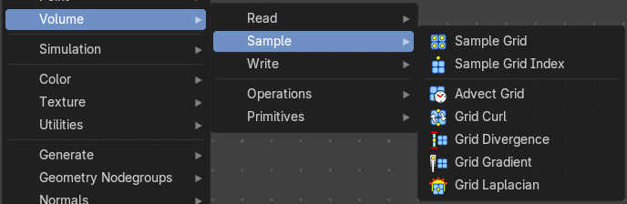
Here you find nodes to modify the volume.

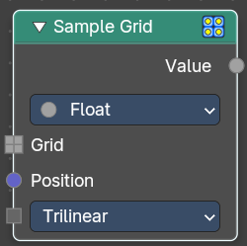
Sample Grid
Retreive values from the specified volume grid.

Inputs

Grid
The input grid

Position
The position field.

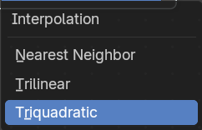
Interpolation
How to interpolate the values between neighbouring voxels.

Input

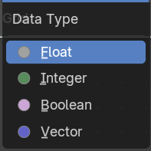
Data Type
Which data type to calculate.

Output

Value
The output value.

Sample Grid Index
Retreive values from the specified volume grid.

Inputs

Grid
The input grid

Position
The position field.

Interpolation
How to interpolate the values between neighbouring voxels.

Input

Data Type
Which data type to calculate.

Output

Value
The output value.

Advect Grid
Move grid values through a velocity field using numerical integration. Supports multiple intetgration schemes for different accuracy and performance trade-offs.

Inputs

Grid
The input grid.

Velocity
The velocity.

Position
The position field.

Time step
Time step for advection in seconds.

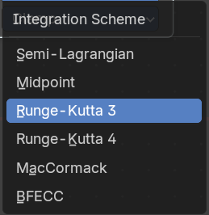
Integration scheme
Numerical integration method for advection.

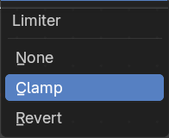
Limiter
Limiting strategy to prevent numerical artifacts.

Output

Grid
The output grid.

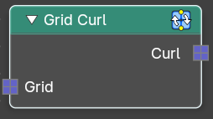
Grid Curl
Calculate the magnitude and direction of ciruclation of a directional vector grid.

Inputs

Grid
The input grid.

Output

Curl
The output grid.

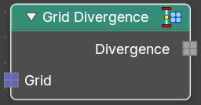
Grid Divergence
Calculate the flow into and out of each point of a directional vector grid.

Inputs

Grid
The input grid.

Output

Divergence
The output grid.

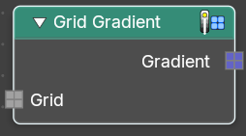
Grid Gradient
Calculate the direction and magnitude of the change in values of a scalar grid.

Inputs

Grid
The input grid.

Output

Gradient
The output grid.

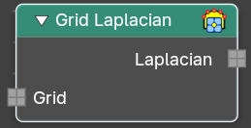
Grid Laplacian
Compute the divergence of the gradient of the input grid.

Inputs

Grid
The input grid.

Output

Laplacian
The output grid.

